

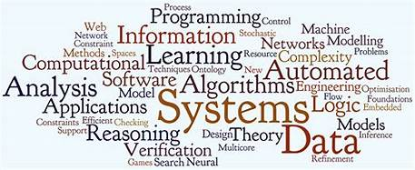



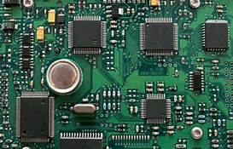

***Individual Project Part 2(IP)***

**Project Report**



Table of Contents

1. Introduction 2

2. ? 2

3. 2

**3.1.** **Open Source Licence** 2

**3.1.1.** **GNU General Public Licence (GPL)** 2

**3.1.1.1.** **About the licence:** 2

4. Reference 3

# 

**Abstract**

In this project, i am going to develop a heart rate monitoring control center

From the point of view of u-healthcare, heart rate is so useful for both illness for taking care of patients and wellness for improving the level of health and wellbeing. It is because heart rate is a significant clinical variable for all kinds of diseases as well as an indicator of the intensity of exercise. Recently, a number of various wearable heart rate monitors have been released to check people`s status in the body by monitoring their heart rates. In addition, a number of smartphone applications have been released to conveniently monitor the status of exercise by using heart rate monitors. However, all of these applications are limited to a personal usage. In this paper, we will design a system to simultaneously monitor heart rates coming from multiple users in a real-time, and develop an Android application to apply the system. The application mainly features a simultaneous monitoring of heart rates coming from multiple users, allowing to be effectively applied to fitness centers.

From the point of view of u-healthcare, heart rate is so useful for both illness for taking care of patients and wellness for improving the level of health and wellbeing. It is because the heart rate is a significant clinical variable for all kinds of diseases as well as an indicator of the intensity of exercise. Recently, a number of wearable heart rate monitors have been released to check people's status in the body by monitoring their heart rates. In addition, a number of smartphone applications have been released to The monitor monitors the heart rate monitor. However, all of these applications are limited to a personal usage. In this paper, we will design a system to monitor real-time,

develop an Android application to apply the system. The application features a simultaneous monitoring of heart rates coming from multiple users, allowing for effective fitness centers.

The aim of this review paper is to summarize recent developments in the field of wearable sensors and systems that are relevant to the field of rehabilitation. The growing body of work focused on the application of wearable technology to monitor older adults and subjects with chronic conditions in the home and community settings justifies the emphasis of this review paper on summarizing clinical applications of wearable technology currently undergoing assessment rather than describing the development of new wearable sensors and systems. A short description of key enabling technologies (i.e. sensor technology, communication technology, and data analysis techniques) that have allowed researchers to implement wearable systems is followed by a detailed description of major areas of application of wearable technology. Applications described in this review paper include those that focus on health and wellness, safety, home rehabilitation, assessment of treatment efficacy, and early detection of disorders. The integration of wearable and ambient sensors is discussed in the context of achieving home monitoring of older adults and subjects with chronic conditions. Future work required to advance the field toward clinical deployment of wearable sensors and systems is discussed.

# Introduction (- scenario where my friend passed away)

As I was brain storming through for an idea for the final year project, an unfortunate incident had happened at the company that I am currently working at. A colleague of mine had just passed away and the news that we received was he passed away to due heart attack while alone at home. His children had went to stay with his divorced wife for the weekend, therefore no one was with him when this had happened. His children only found his body when they came back home. This is a real thing, not a joke (as shown in the figure below).

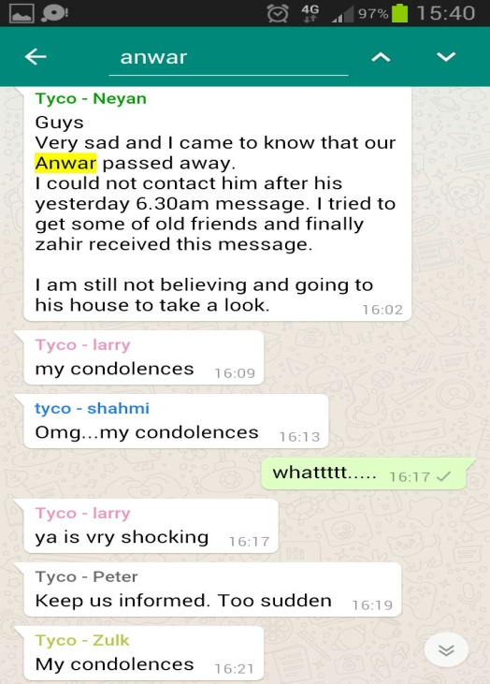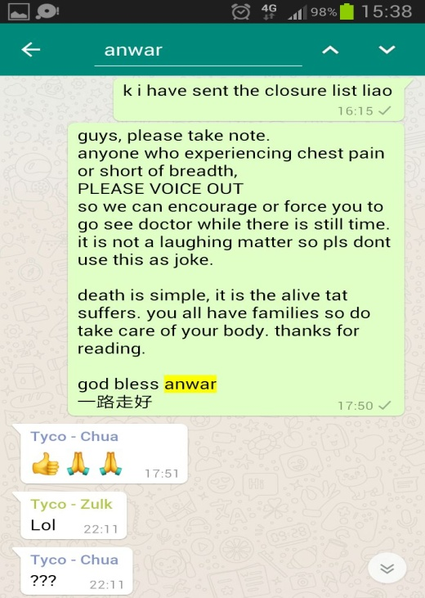

If only there was someone at home or nearby him who was able to call for help immediately or perform emergency Cardiopulmonary Resuscitation (CPR) on him, then he would have been saved.

**Would like to find a way to prevent**

That was where I started to think, are there any ways to help prevent this kind of situation from happening? I know I am not a doctor, therefore I can't find ways to cure heart attack but at least I can try to find a way to prevent as prevention is always better than cure. So instead of finding a cure for heart attack, I should look in the direction of how to improve the survival rate during heart attack. What are the possible ways of prevention? how and what are the alternate ways of allowing other people know that you are in danger where you are unable to call for help. When a person is in danger, he or she probably already reach a point where they are unable to help themselves, not to say call/shout for help (example fall into concussion, the whole body feels weak, don't even have the energy to talk, fainting). A lot people lost their lives due to the waiting time for treatment or for ambulance to arrive.

So, is there such a device that is able to provide warning or request for help?

**What is heart attack**

First we must have a brief understanding of what is the illness here before we can proceed further. As researches shows that there are actually few types of heart attack. When heart attack occurs, depending on the person's body, could be heart beating slower and slower or beating faster than normal.

Bradycardia is a slow, abnormal or irregular heart rate condition where the heart beats under sixty beats per minute (BPM). It can be a very serious problem when the heart isn't providing enough oxygen throughout the body thus causing the person to feel dizziness, shortness of breath, fatigue, lack of energy, sweating, weakness in body or fainting spells (Mark 2017).

Tachycardia is a type of heart rate disorder where the heart rate beats faster than normal and exceeds the normal resting rate. At the point where the heart pulsates too quickly, it pumps less proficiently and lesser blood flow to the remaining of the body causing lack of oxygen to the myocardial cells which leads to heart attack (Christian 2017).

**What Is a Heart Rate Monitor?**

Heart rate monitor (HRM) devices are mostly utilized to gauge the intensely of a person exercising by measuring the heart beats per minute in real time or recording for later studies. The information collected can be immensely beneficial for the person using it. Example, for cardio patients, it can help them to keep track and stay within the safe zone on a daily basis or for exercisers, they can use it to monitor their heart rate during their exercises to guide their workouts. Depending on the person using the heart rate monitor, each objectives may vary (Kim 2013).

**https://www.rei.com/learn/expert-advice/heart-rate-monitor.html**

**Types of Heart Rate Monitor**

There are few types of heart rate monitors in the market but the most common and popular types are the wireless chest strap, pulse monitor wrist watch and finger to wrist method. Basically, the heart rate monitor is split into electrical pulse, in-ear measurements, optical technology.

**Chest strap heart rate monitor (electrical pulse)**

A wireless sensor is mounted onto the chest strap (require wet, moisture contact with the skin around the chest area just underneath the bosom, to get precise readings) will distinguishes the heart beat electronically by detecting the electrical activity (electrical signal emit off by the heartbeat) using the transmitter and rely the information to a receiver, which will displays current heart rate. The chest strap provides the most accurate heart beat information as compare to other types of heart rate monitors (Nederhood 2016).

Pros: Chest strap types provide nonstop heart beat readings and allow one to move uninhibitedly, so they are useful for practically any type of exercises e.g. badminton to soccer and such. Some athletes preferred chest-strap models to the wrist-only models as they can have a records of the activities without stopping to touch the device to take a reading.

Cons: One have to wet the chest strap first to get a reading and some of the models requires to send the heart beat to a mobile phone, which can be inconvenient for individuals who might rather not carry their phone while working out. The elastic band that wraps around the body with electrode pad may feels uncomfortable to most individuals.

**Optical heart rate monitor (optical sensing technology)**

Optical heart rate monitor gather heart beats data from "photoplethysmography" (PPG) which is a process that utilizes the light shining through the skin and interacting with the flowing blood in the veins to measure the blood flow. Optical emitters from the built-in sensor in the monitor emits different wavelengths of light and interact with the blood flowing under the skin. The light refracts off the flowing blood and another sensor in the monitor captures the light scatters information. The information can then be processed with algorithms to deliver understandable heart beats readings. Optical sensing technology are currently used on wrist band, arm band, ear bud, temple, finger to wrist (Palladino 2017).

Pros: Continuous real time heart rate information as chest straps and feels more comfortable when wearing on wrist or arm as compared to strapping on the chest.

Cons: More expensive and less accurate as compare to chest strap using electrical pulse technology and may not get readings from tattooed or dark pigmented skins. Tougher to use and more distracting as there are many other inbuilt functions.

**Why choose this product?**

I chose optical heart rate monitor (wrist band) as it is a popular way of measuring the heart rate of individuals. And existing market already have a lot of different brands of smart watch or wrist band that was created to help individuals take care of their health.

**Ways of integration of existing solution**

My idea is to integrate existing market solution and come up with a product where allows to inform others as these products are basically just for individual taking note of their health status. If there is a control centre where the centre can monitor the status of other personal, and able to get real time updates, won't that be a much better solution to reduce the chances of people dying from heart attack alone at home, at work or at any place.

**Idea can also use in what other situation**

There are many situation where a people tend to be alone be it work or not working .

Imagine a person is having a evening run alone in the park where not many people are around and suddenly, that person have a heart attack and fall to the ground. Since he is suffering from heart attack, he has no chance of giving himself self help and would require others to provide assistance. But if there is a device that is able to detect the changes in his/her heart rate and quickly give notification to his/her dearest. His/her family member could first thing rush to his/her side and provide assistance before it is too late.

Imagine a child got lost which shopping with his/her parent. The parent was busy looking at items to purchase without realising their child has got lost. The child got panic and started to cry, his/her heart rate will also increase due to the panic and a notification was immediately sent to his/her parent. The parents will have first time notices of something went wrong with their child.

Imagine a teacher taking a class of thirty students for a physical exercise which is running around the school compound. That teacher probably won't even be running together with the whole group and would be just waiting at the ending point. Suddenly, a student have heart attack and fallen on the ground. The surrounding students near that fallen student will probably be in a shock where they just stood on the ground, unable to do anything. But if the device sent a notification to the teacher, that teacher can get first thing notices and rush to the fallen student as soon as possible and provide emergency first aid.

There are many real life scenarios that had happened before and most of these cases actually can help save a person's life. With immediately CPR perform on the fallen person, there are many chances of able continuous physical pumping of the heart while waiting for the ambulance to arrive to the scene before everything is too late. Every minute counts to prevent a life being lost therefore prevention is always better than cure.

**Idea**

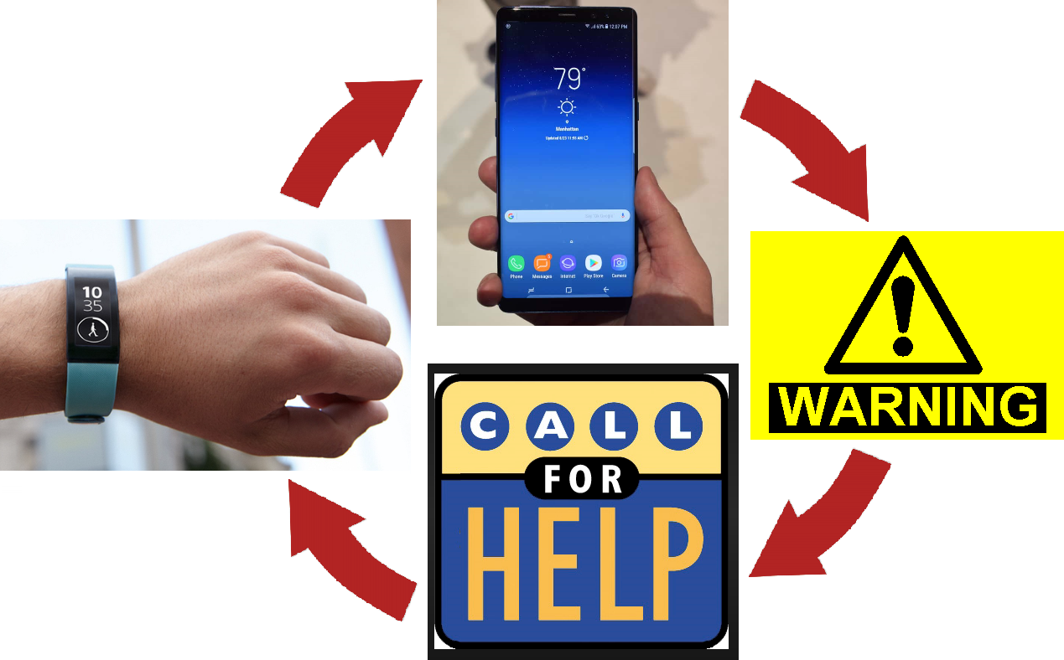

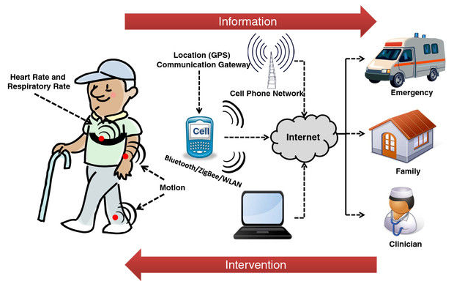

https://jneuroengrehab.biomedcentral.com/articles/10.1186/1743-0003-9-21

The idea is:

1) The individual wears the smart band on the wrist to monitor his/her heart rate at real time. The smart band will then transmit the data collection from the sensor in the smart band and pass through wireless connection to the smart phone.

2) The application in the smart phone will process the transmitted data collected by the phone and compare to the initial settings that was set in the application.

3) Once the real time heart rate exceed the danger zone settings, the application will request the smart phone to send notification to get for help.

4) Assigned help centre received the call or message and immediately proceed to the individual in distress.

Basically, this idea is split into two parts which are:

1) smart watch/band

2) application in mobile phone

**Description of existing wrist band**

From existing market solution, I chooses wrist band for the small, slim and most important inexpensive as a solution to my life. But existing wrist band only collect data of heart rate for themselves. And my idea is to create a control centre and a way to connects these wrist band together.

**Purchasing product to start prototyping**

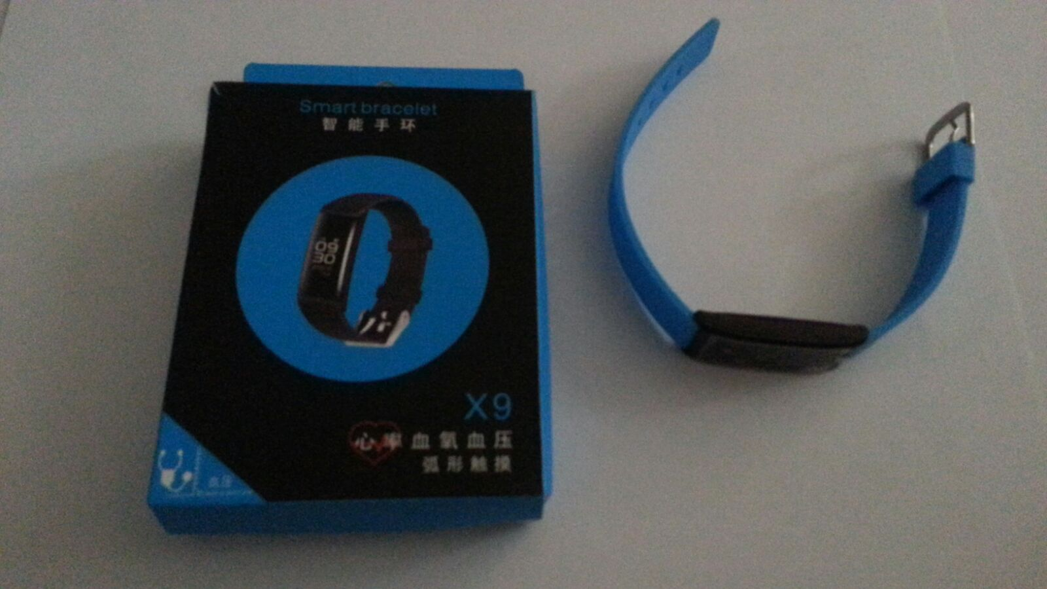

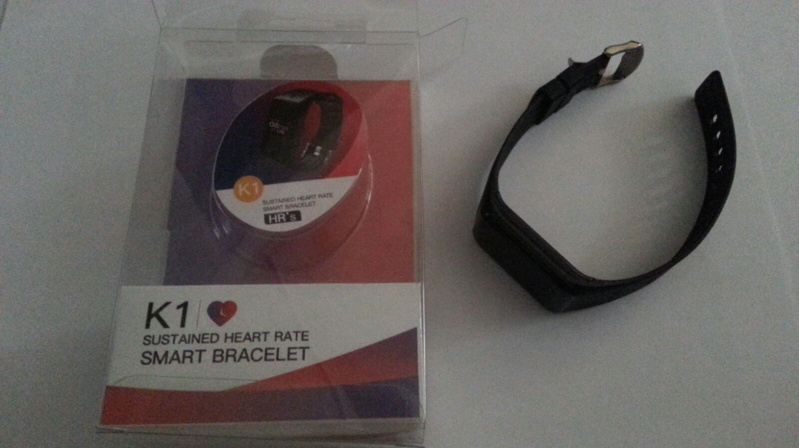

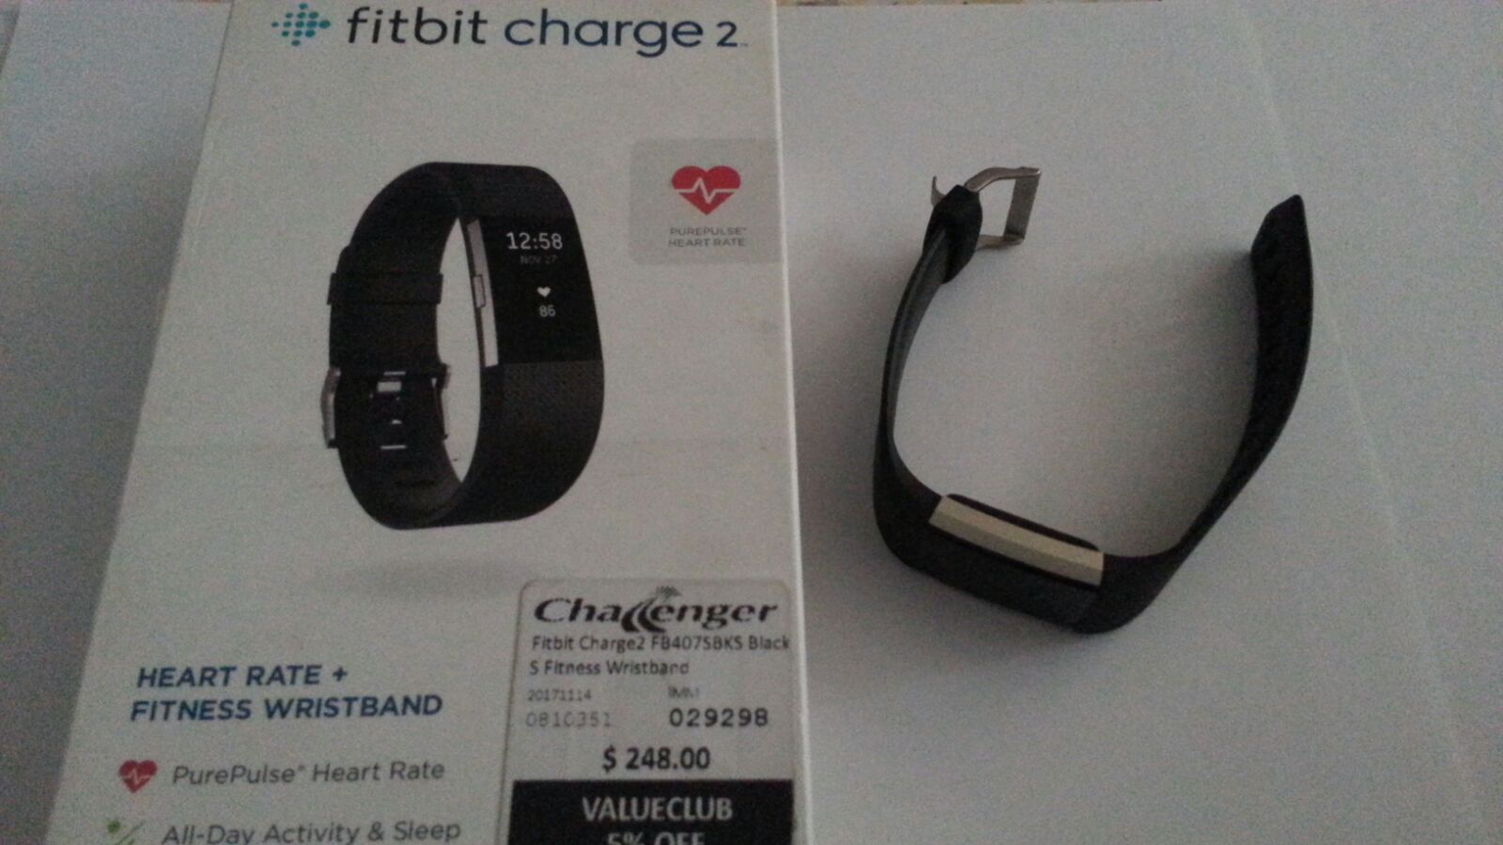

**Start off**

To start off the project, the first thing to do is to use the smart bands that I have purchase. The three smart bands each are able to measure real time heart rate though the accuracy are a bit off when compare the three of them together. Next, is to create an application that can capture the heart rates which in this case, I am using android studio (as there was a lesson previously which taught us on android application development AAD)

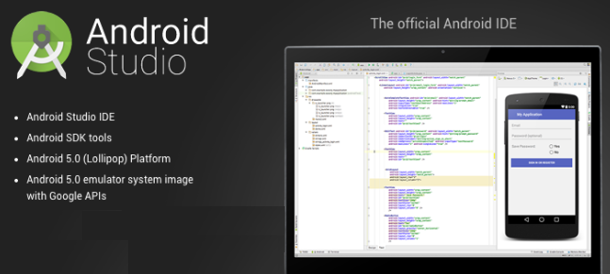

**Problems Encounter**

The moment I started designing the application in android studio, I immediately bumped into obstacles. It seems that I as a third party developer does not have the access to data transmitting out from the wearable, so I started to explore into this area of domain.

**Problem domain**

There are many companies that create and produced many variety of devices and software configurations as each company treat the rest as competitors thus a lot information are kept secret in order not to lose out to each other thus resulting in fragmentation problem in the wearable and smart phone domain.

As shown in the figure below, there are many different companies under the "others" option for the wearable devices. Although the wearable devices are being developed in many ways, it is still possible to classify the group into two types of categories which are smart bands and smart watches. These companies developed their own software platforms involving multiple systems for users and third party developers usage (Example applications, Software Development Kits and RE presentational State Transfer Application Programming Interfaces)

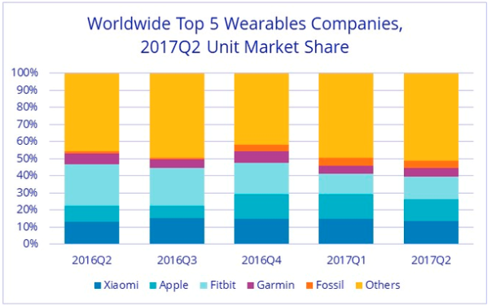

Each company develop their own platform that empowers the accumulation of information. By utilizing the services accessible on these platforms, both the users can gain access to the gathered information and third party developers can fabricate new applications and services under certain conditions given by the company.

**Data Collection**

Wearable devices permit different ways distinctive manners by which information from the sensors can be gathered by other different frameworks. In the figure shown beneath, demonstrates the several different frameworks that can be engaged in the smart watch information gathering situation example smart phone, wearable, computers, servers and cloud services. Two types of frameworks that are recognized are the proprietary and third party.

Proprietary systems provided and maintained by companies are used to collect users' information, to perform investigation and to give information and scientific outcomes to users and to approved third parties.

Third party system such as services, applications for wearable devices and smart phones, and software programs for computers can be developed and maintained by external entities to provide particular functionalities. Every one of these segments is proposed to perform some particular capacities:

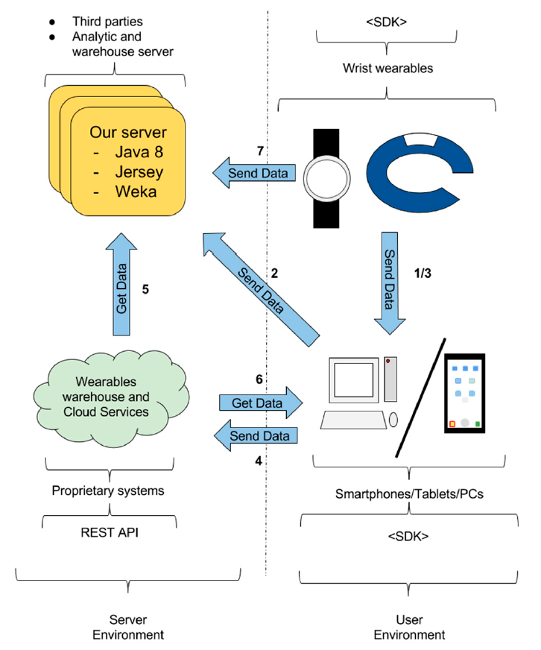

In addition to the platform, each smart watch includes a native SDK empowering the development of apps however with no particular support for a sensors gathered information exchange. Utilizing these native SDK it is conceivable to create applications that gather information from wearables and transfer it through non specific correspondence facilities (e.g. Bluetooth, WifFi). These solutions are ad-hoc, involve high complexity and many issues, such as battery drains. Therefore, we concentrate the attention on the solutions provided by the companies to support information accumulation and transfer in an integrated way.

**Data Transfer**

Two types of transferring data:

1) Warehouse data transfer - Taking the data from proprietary warehouses.

Warehouse data systems have to keep up to date as all the data are transferring from devices to the cloud through their services and these data are then stored into the warehouse. Inserting to and extracting from warehouse are based on scheduled data transfer (Comparatio 2008).

2) Wearable data transfer - Taking the data directly from the wearable sensors.

Comparing warehouse data transfer to wearable data transfer, warehouse data transfer has some distinct disadvantages such as collection of data in real time mode. Transferring of information from wearable devices to the proprietary warehouse could be at random, depending on the schedule timing of transferring defined by the companies developers. Sometimes, the setting of transfers timing can even be a few days to a week. As for wearable data transfers, the data transfers can be created at particular time interims. Raw data can be capture from wearable data transfer where as data has undergo some processing before transferred to proprietary warehouse.

Two methods of accessing data:

1) Direct access - third party accessing data directly from wearable or warehouse

2) Indirect access - gateway between data from source

----------- must rephrase

In both modes, wearable and warehouse, it is possible to further distinguish between two options in which access to data can be produced

Taking into account these two transfers and accessing options, four different configurations can be distinguished

**Method 01 - Indirect access for Wearable data transfer**

The transferring of data utilizing the smart phone application to the third party system after collecting the data from the wearable as shown in the figure below.

1) Interface 1 (in the figure below) - A native application inside the smart phone act as a listener to grab the events from the wearable device though either Wi-Fi or Bluetooth.

2) Interface 2 (in the figure below) - A native application inside the smart phone sends the information collected from the wearable device to the server. (the smartphone app stores the data gathered from the wearable while the internet connection is not accessible.)

This method will need gigantic effort in developing an application that will run in the smart phones first and then grabs the events from the wearable device. In addition, for some wearables, we also need to develop an app for the wearable to record the sensor data and to transfer it to the smartphone app.

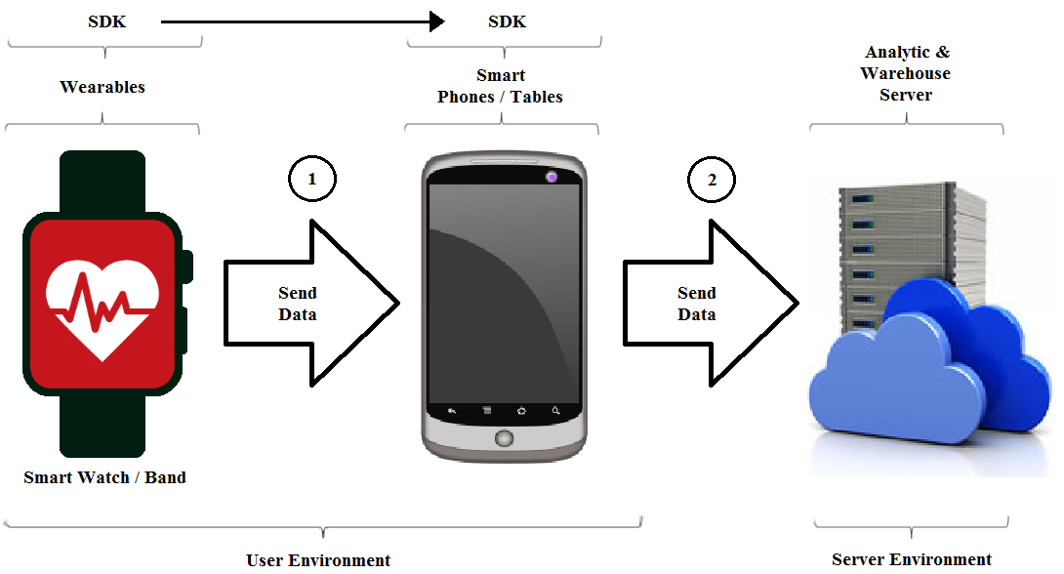

**Method 02 - Direct access for Wearable data transfer**

1) Interface 3 (in the figure below) - This method requires the wearable device to collect the information gathered from the sensor within the device and direct access to the web servers to transfer the information, provided with internet connection ability example build-in SIM card or Wi-Fi access. In addition, the energy consumption is too high. Therefore, this configuration is not a valid option yet.

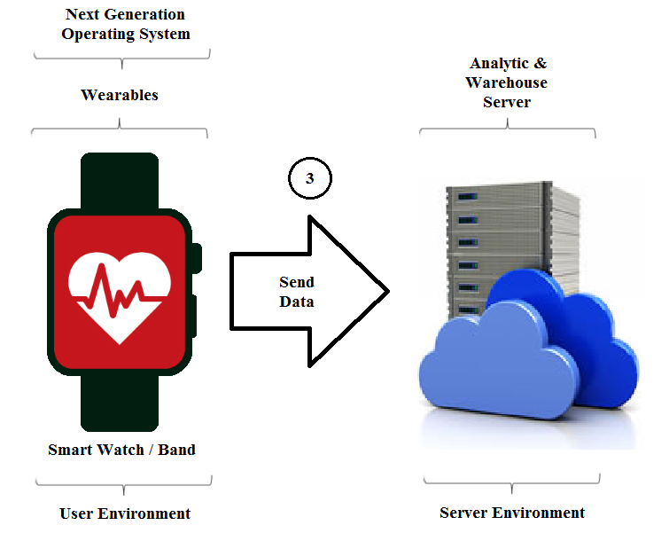

**Method 03 - Indirect access for Warehouse data transfer**

This configuration involves indirect access to the proprietary warehouse using an intermediate smartphone. Figure 7 shows the way in which data can be transferred through link 6 and link 2. From the previous configuration, an app running on the smartphone/tablet obtains the data from the proprietary warehouse and cloud service. Next, this app sends the data to the third-party server. This configuration is needed in the cases in which the warehouse does not provide a REST API but it allows operation from the SDK.

This setup includes roundabout access to the restrictive stockroom utilizing a middle of the road cell phone. Figure 7 demonstrates the manner by which information can be exchanged through connection 6 and connection 2. From the past arrangement, an application running on the cell phone/tablet gets the information from the exclusive stockroom and cloud benefit. Next, this application sends the information to the outsider server. This arrangement is required in the cases in which the stockroom does not give a REST API but rather it permits task from the SDK.

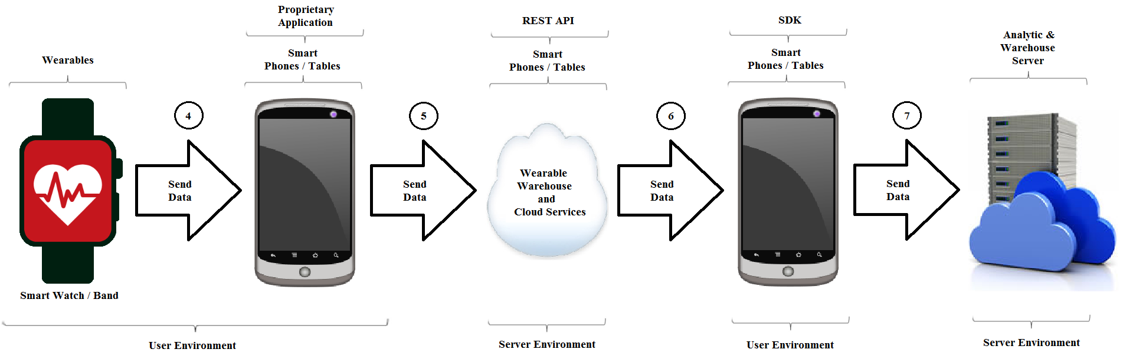

**Method 04 - Direct access for Warehouse data transfer**

The third party server obtains the data using the proprietary warehouse REST API. (figure)

Link 3. The wearable sends data to its proprietary warehouse. This is performed through the proprietary transfer solution. This solution is based on an app running in an intermediate smartphone or PC, which acts as a gateway towards the server. In the cases we studied, the wearable sends the data to the intermediate app using Bluetooth. This transfer is performed periodically because of the energy demands of the Bluetooth connection. Depending on the wearable, if this transfer cannot be performed for a long time, the data can be summarized or even lost.

Link 4. The data is transferred from the intermediate smartphone or PC to the wearable warehouse.

Link 5. The wearable warehouse receives requests from third-party systems through the REST API. Then, the warehouse delivers the requested data.

The outsider server acquires the information utilizing the restrictive stockroom REST API. (figure)

Connection 3. The wearable sends information to its exclusive distribution center. This is performed through the restrictive exchange arrangement. This arrangement depends on an application running in a moderate cell phone or PC, which goes about as a portal towards the server. In the cases we examined, the wearable sends the information to the middle of the road application utilizing Bluetooth. This exchange is performed intermittently as a result of the vitality requests of the Bluetooth association. Contingent upon the wearable, if this exchange can't be performed for quite a while, the information can be condensed or even lost.

Connection 4. The information is exchanged from the middle of the road cell phone or PC to the wearable stockroom.

Connection 5. The wearable distribution center gets demands from outsider frameworks through the REST API. At that point, the distribution center conveys the asked for information.

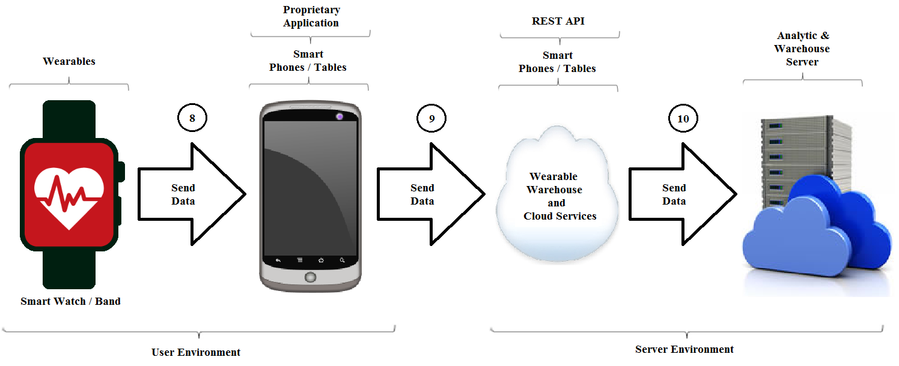

Data Transfer Options by Platform

The three main software platforms in the smartwatches domain support different options related to the data transfer, (cf. Table 2). In the table, we can see how each vendor supports different data transfer modes. The warehouse data transfer—direct access is the most commonly supported one.

Data Integration

This section introduces issues related to the differences among data coming from wearables of different vendors. Data such as HR, number of steps, speed or body temperature is arranged in accordance to particular vendor specifications and differences can be found at several points: data models, identification, vocabularies, availability on time, etc. As a result, it is not possible to work with data collected from different vendors directly. A homogenization process is needed to get data in accordance to the same conventions. The next sections describe these differences focusing on sleep features, because it is our research field, and these issues can be found in other fields.

4.1. Differences in Data Models

Data collected from wearables is arranged in temporal segments according to different models. Each model can be described in terms of the elements and attributes included as key-value pairs, as in a typical XML (eXtensible Markup Language) or JSON (JavaScript Object Notation) specification. In the case of sleep data, the following arrangements can be found:

Microsoft manages each sleep period as a different object, named as a sleep segment. When the user moves from light sleep to deep sleep, for example, a new sleep segment object is produced. Each sleep segment includes its own start and finish date object and type of sleep (cf. Listing 1).

Google Fit. It uses a structure based on segments similar to the Microsoft Band. Each segment includes the start and finish time and it is tagged with the sleep state.

Apple Health. Its model is also based on segments, but in this case segments can be overlapped [30]. It is possible to find segments in which the user is in bed but not sleeping and other segments in which the user is in bed and sleeping. Situating the segments along a temporal axis, it is possible to know the different sleep states of the user, the total sleeping time, the awake time, etc.

Fitbit. The sleep record is represented minute by minute (cf. Listing 2). Each minute is tagged with the sleep state of the user.

In Jawbone, there are segments indicating a new sleep period, but there is no information about the end of the period (cf. Listing 3).

Temporal Discrepancies

In addition to the variety of data models, differences can also be found in the identification of the traces. In the case of the sleep periods, it is important to identify the concrete day at which such a period is produced. This can be seen as a trivial task, but different vendors attribute it in different ways:

Microsoft identifies different sleep periods using a single identifier for each day. Therefore, if a user sleeps from day 6 to day 7, that sleep period is assigned to day 6. If the user sleeps after midnight, the sleep period is assigned to the next day. As a result, the data can show weird things: some days the user does not sleep at all, while other days he/she sleeps almost all the day.

Fitbit identifies each sleep period using a different identifier. For each day, one of the periods is marked as the main one and the other periods, if available, as naps. If a user sleeps from day 6 to day 7, the sleep period is assigned to day 7.

Jawbone follows an approach similar to Microsoft. Nevertheless, if a user sleeps from day 6 to day 7, the sleep period is assigned to day 7.

4.4. Differences in Counters

Different vendors follow different approaches to count events produced. More precisely, they vary the way in which counters are reset. Microsoft Band counts all the items (e.g., number of steps, calories or distance) produced from the last formatting of the device. On the contrary, Android Wear devices reset their counters when the clock of the device is rebooted. In a different way, Fitbit counters are reset every day. Obviously, these differences need to be taken into account if data from different sensors need to be integrated or compared.

For my case, I will look into heart rate suddenly beat very fast.

- convince self why this idea is good

- bump into error

- exploring ways to overcome error

- why, what, when, where, how

- alternative ways/solutions

- building prototype base on new idea

- testing

# Reference

Christian, N. (2017) *Tachycardia: Causes, Symptoms, and Treatments* [online] available from <https://www.medicalnewstoday.com/articles/175241.php> [3 March 2018]

Comparatio, U. (2008) *Data Warehouse - Data Transfer* [online] available from <https://it.toolbox.com/blogs/comparatiousa/data-warehouse-data-transfer-032808> [5 March 2018]

Kim, A.Z. (2013) *Heart Rate Monitors: How They Work* [online] available from <https://www.livescience.com/42220-heart-rate-monitors.html> [4 March 2018]

Mark, W.L. (2017) *Sinus Bradycardia: Background, Pathophysiology, Etiology*. [online] available from <https://emedicine.medscape.com/article/760220-overview>

Nederhood, M. (2016) *The Best Heart Rate Monitor* [online] available from <https://www.techlicious.com/review/the-best-heart-rate-monitor/> [4 March 2018]

Palladino, V. (2017) *How Wearable Heart-Rate Monitors Work, and Which Is Best for You* [online] available from <https://arstechnica.com/gadgets/2017/04/how-wearable-heart-rate-monitors-work-and-which-is-best-for-you/> [5 March 2018]

-- A Simultaneous Real-Time Heart Rate Monitoring System for Multiple Users

http://www.koreascience.or.kr/article/ArticleFullRecord.jsp?cn=JBCRIN_2015_v4n8_253

-screenshot of codes then explain

-unit test

- acceptance test

-mvc model model view controller framework

- schedules /timelines

https://onecellonelightradio.files.wordpress.com/2015/03/wearable-internet-of-things-seamless-sensingwirelesshealthcare.pdf - IOT architectural